Assignment 3: Model behavioral analysis

Hélène van Heijningen 4076850 Date: 8th of December, 2014

Matthijs Brouns 1505157

# 1. Formulate a dynamic hypothesis of your variable of interest

The variable of interest that has been chosen for this assignment is the stock variable ‘Planned infrastructure’. We chose this variable because of the different types of behaviour occurring over time. This makes this variable very suitable for the type of analysis we are applying in this assignment. We will now discuss the dynamic hypothesis of the ‘Planned infrastructure’ variable.

Since the amount of available infrastructure at the start of the model is much larger than the infrastructure demand, no infrastructure will be planned until the infrastructure surplus empties and infrastructure aging causes new infrastructure to be planned, which occurs are around year 5.

Then exponential growth will occur as there is now a steep growth in the infrastructure shortage. A lot of infrastructure needs to be planned at the same time which causes this type of behaviour.

Next the ‘Planned infrastructure’ will slowly stop climbing as much, showing a logarithmic kind of behaviour. This is because the staff availability has become a limiting factor in the system and because of this there is not enough staff available to plan all the necessary infrastructure.

The ‘Planned infrastructure’ now starts to decline exponentially and then at the end logarithmically, as it is now showing goal-seeking behavior. The ‘Planned infrastructure’ stabilizes at 100Ml infrastructure planned per year which is the amount the limited amount of available staff members can plan.

The different types of behaviour are visualized in figure 1. The red line represents the ‘Planned infrastructure’ and the blue line is the second derivative of the ‘Planned infrastructure’ variable, normalized between -1 and 1. When the second derivative is positive it shows exponential behaviour and when it is negative there is logarithmic behavior.

Figure : Behavior of chosen variable 'Planned infastructure' (red) and the normalized second derivative of this variable (blue)

# 2. Setting up the analysis

We have selected the period of 0 to 20 years to perform the analysis on. We have chosen this period because in this period all the different types of behavior occur; linear, logarithmic and exponential. This period includes 6 intervals with different behaviors. We have chosen to include a relatively high amount of intervals because we are interested in analyzing the entirety of the behavior of this variable and not only parts of it. Furthermore, the period is bounded at 20 years because the last interval and type of behavior is still taken into account but since there are no other types of behavior during the entire model run it is easier to cut the period off at 20 years.

We have identified 4 candidate loops that we think will strongly influence the behavior of the ‘Planned infrastructure’ variable. The 4 chosen loops and many other loops influencing the chosen variable are visualized in figure 2.

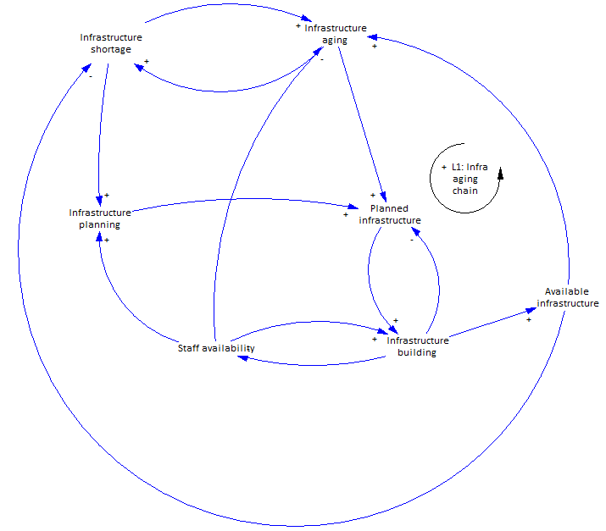

Figure : Four chosen candidate loops that influence the stock variable 'Planned infrastructure'

We have chosen 1 loop that shows the influence of infrastructure aging on ‘Planned infrastructure’. We chose this loop because the sensitivity analysis showed us that the planned infrastructure is relatively sensitive to infrastructure aging, in fact this relation turned out to be the most sensitive relation in the model, which is why we believe it could strongly influence the behaviour of the ‘Planned infrastructure’ variable. The next 3 loops all have to do with staff availability. We chose on these types of loops because initial model testing showed that staff availability is a very important limiting factor in the model which also greatly influences the planning of infrastructure. We therefore believe these loops will strongly influence the behavior of the ‘Planned infrastructure’ variable.

One of the staffing loops reduces the amount of infrastructure which can be planned due to limited staff availability. The second loop reduces the amount of infrastructure which can be built due to limited staff availability and the last loop increases the infrastructure aging when less maintenance can be carried out due to limited staff availability which means more infrastructure needs to be planned.

# 3. Method of deactivations

The loops have been deactivated by removing the effect of infrastructure aging and staff availability respectively. For the first loop this means in practice that the equation of the infrastructure aging flow is changed from (Theoretical infrastructure capacity/infrastructure aging time) to (Theoretical infrastructure capacity/infrastructure aging time)*(1-Turn of loop 1) so that when ‘Turn of loop 1’ equals 1, there is no infrastructure aging anymore. This way there is no such effect on the planning of infrastructure.

The second loop uses the same method to shut down part of the ‘infrastructure planning’ equation which includes the effects of staff availability on the planning of infrastructure. The third loop once again uses the same method but now in the equation of ‘build infrastructure’ to shut down the effect of staff availability on the building of infrastructure. The last loop uses the same method, but this time in the equation of ‘Effect of maintenance on aging time’ to make this equation equal to 0 so that maintenance no longer influences aging time.

We have chosen this method because by easily changing the value of the ‘turn of loop X’ variable from 0 to 1 from a certain time to test for the different intervals by using a PULSE function, we were able to shut off one loop for different intervals and see the change in behaviour compared to the baseline scenario.

# 4. Execute the Analysis

…

Timeslot 1, turned of loop at t=4.5



Timeslot 2, turned of loop at t = 6



Timeslot 3, turned of loops at t=9



Timeslot 4, turned of loops at t=12



Timeslot 5, turned of loops at t=13.5



# 5. Discussion

…